**Proctor & Gamble Crisis Response “Tide Pod Challenge” PR Case Study**

**Lillian Adams, Emma Pall, Ella Kate Reynolds, Madison Hiser**

ADPR – 3743 PR Principles

Professor Chung

University of Arkansas

**Situation**

In 2018, a new trend emerged on the internet and with the help of various social media platforms such as Twitter, YouTube, and Instagram, quickly gained traction and many willing participants. This challenge encouraged willing participants, mainly adolescents and young adults, to attempt to eat the laundry product of a tide pod. These detergent products contain a high concentration of harmful chemicals and if ingested cause serious illness such as seizures, cardiac arrest, severe vomiting and in rare cases, death (AAPCC, 2022). According to the American Association of Poison Control Centers, in the first month of 2018 alone there were 86 cases of reported intentional misuse of the laundry packets among teenagers (Nastasi, 2018.) Videos on YouTube generated high amounts of traffic, receiving views anywhere from a dozen to hundreds of thousands depending on how the algorithm pushed the content. Tide Pods were being mentioned every 6 seconds on social media and receiving 14,036 mentions a day at the height on the challenge in early 2018 (Swan, 2018). Along with videos of people trying to consume the tide pods going viral, false twitter accounts were created posing as Tide and posting content encouraging individuals to attempt the challenge. Although Proctor and Gamble, the parent company of Tide, did nothing to encourage the challenge or cause it to even become a challenge in the first place, the company still had an obligation to respond and try to stop teenagers from consuming their hazardous product in hopes of a moment of online fame.

*Graph obtained from data provided by Linkfolio*

**Research Summary**

Research that will better communicate key messages:

1. Define the target audience: acquire information on who is being exposed to the challenge and therefore who is more likely to take part in it, ultimately putting themselves at risk for possible harm.
   1. Track demographics and psychographics of Twitter users engaging and creating content revolving the challenge.
2. Develop an effective message: understand how the target audience best sends and receives messages to construct a clear message that can separate itself from media clutter.
3. Formulate a strategy: knowing what social media platforms need to be implemented to communicate key messages and increase awareness.
   * 1. Partnership with YouTube and Twitter.
     2. Measure overall views and engagements on social media posts to ensure that the message is being spread across the vast audience.

**Objectives**

The objectives are:

1. Decrease the number of young adults participating in the challenge to near zero levels by collaborating with social media platforms to either block or restrict content that promotes dangerous activity. (Informational objective)
2. To increase online awareness that the potential bragging rights and temporary internet fame is not worth the danger of potential lethal poisoning and bodily harm after attempted consumption of a Tide Pod. (Motivational objective)

**Target Audience:**

The target audience for the message here is a unique one. Teenagers were the main participants in the challenge and therefore needed to be warned about the potential dangers if a tide pod is ingested. The psychology behind trends and what drives teens, who are consciously aware of the potential danger presented to them, to participate in the challenge is also a unique and complicated component to appeal to. Teenagers are a complicated audience to work with. They’re at the age group where they can read the clear warning labels on the products packaging warning against ingestion, and they are also able to bypass the child-proof packaging meant to prevent consumption from toddlers. Teenagers are risk-takers and even though they hold the brain development to process potential danger, tend to take part in dangerous activities anyways. At a young age, there is a strong desire to appeal to peers despite the potential consequences which leads to teens taking part in dangerous activities. There is a stronger feeling of distress among teens when they feel as if they are being left out or rejected by peers and since the brain is still developing in these stages, teens are less likely to measure risk when finding solutions to resolve these feelings of distress. With social media, the age-old threat of peer pressure has now been amplified to platforms with millions of users encouraging the behavior and is no longer limited to their friend groups. Studies suggest people become more susceptible to social influence around the age of twelve (Fleming, 2020).

**Strategies**

* Implement a strategic social media outreach plan to effectively communicate the dangers of ingesting Tide Pods to young adolescents. This will discourage participation in the challenge and will prevent any further harm being done to more individuals by decreasing overall attempts.
* Key messages the campaign wants to get across to the target audience:

1. **Ingesting a Tide Pod imposes a serious health risk.** This emphasizes that the online attention that may be generated by participating in the trend and posting a video of it is not worth the risk of the serious illness that may result from it.
2. **Tide Pods are for laundry only.** This restates the original, and only use, of the product and despite what may be encouraged by one’s peers online an individual should not attempt to consume a pod because it contains harmful chemicals that were never designed for human consumption.
3. **Address public concern, do not apologize, or assume guilt for the challenge.** P&G could not have any responsibility for the hazardous challenge and therefore did not apologize and assume guilt. This controlled the narrative and while the validation and acknowledgment of public concern was the correct thing to do, avoidance of an apology was also necessary because it put the emphasis on the consumer responsibility and misuse of the product. This also helps avoid a legal liability because it avoids claiming any responsibility (Reed, 2018).

**Tactics**

1. Social Media –
   1. Partner with YouTube and Twitter to utilize algorithmic systems and restriction guidelines to either fully remove or age-block content either encouraging or engaging in the online challenge. YouTube’s community guidelines prohibit any content that is ‘intended to encourage dangerous activities that have an inherent risk of physical harm’ (YouTube 2022). The Tide Pod challenge directly encourages self-inflicting potential bodily harm putting it into direct violation with the company’s guidelines. Any content revolving an attempt, or an encouragement of an attempt will be removed, and the creator will retrieve a ‘strike’ which will negatively impact their ability to post and monetize content on the platform in the future. Twitter will remove any content, once flagged, that encourages self-harm or any false accounts impersonating Tide’s official account to spread misinformation (Twitter, 2022).

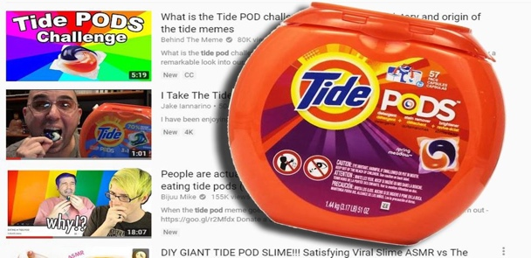

*Screenshots from Tide Pod Challenge and example of restricted video*

* 1. Integrate brand messages into organic media regarding the trend. To gain the attention and communicate with the target audience, P&G should avoid a simple text post warning of the dangers of the challenge because it would lack high levels of traffic. Instead put together meme-looking, slightly comedic, posts that gain similar amount of traffic levels as media already circulating around the challenge (Reed, 2018). Use two-way communication by keeping on online replies and comments to emphasis the danger to users who still may not understand the severity of the potential outcomes.

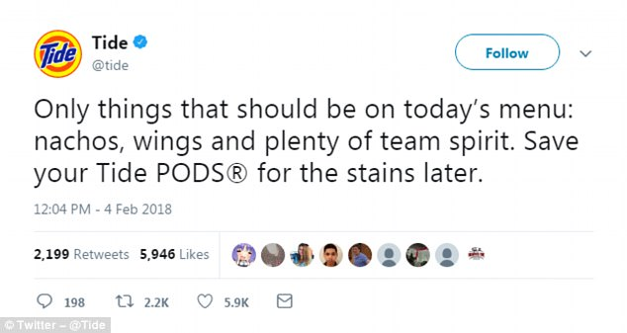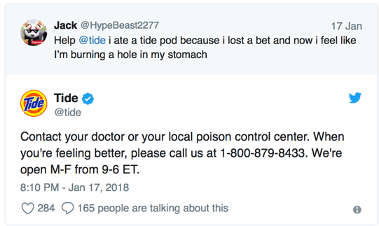 *Screen shots from Tide’s Twitter account*

1. Celebrity Spokesperson – Appeal to the target audience by partnering with an individual popular among them, in this instance National Football League star Rob Gronkowski, to discourage taking part in the challenge. Gronkowski is the right fit for this role because his acclaimed personality aligns with one of a teenager’s and is one, they would most likely view as a fellow peer rather than another person of authority. His known blunt personality and habit of reckless behavior matches well with the delivery tone of the message that this is a serious health risk and should not be attempted under any circumstance. At the time of the viral challenge, Gronkowski was already partnered with another adolescent familiar network, Nickelodeon, with his 35-episode series ‘Crashletes’ so he’s already a familiar face that adolescents simultaneously looked up to as well as related to (Stites, 2018).

*Screenshot from video collaboration with Rob Gronkowski*

1. Press Release via CEO – Have P&G CEO David Taylor release an official statement to various large-scale media outlets. The press release should both emphasis that P&G has no responsibility for the challenge to become so viral or a thing at all and that there is very little the company can do to prevent misuse when misuse is intentional. Have the statement also include what measures the company is doing to shut down the challenge from gaining anymore online traction.

**Evaluation**

1. **Track Tide Pod Challenge mentions and cases of intentional misuse** 
   1. Partner with the American Association of Poison Control Centers to obtain accurate reports on intentional misuse of the product to track a downward trend
2. **Measure consumer attitudes towards Tide Pods** 
   1. Certain companies put their own playful spin on the challenge. Hurts Donuts company made their own edible version of a Tide Pod following the trend and prompted the limited-edition item on a post saying ‘This is a donut…you can eat this! Tide is for laundry silly’ (Caplan, 2018).
   2. Track responses from major media outlets and consumers on media posts
3. **Track purchases of Tide Pods or Tide products** 
   1. On December 31st of 2017, only 38% of consumers were either actively buying Tide products or considering buying them. By the end of January of 2018 that number jumped 3 points up to 41%. The popularity and controversy revolving the challenge may have boosted brand awareness among consumers (Marzill, 2018).

*Graph obtained from YouGov measuring consumer attitudes*

**Bibliography:**

Hirsch, L. S. (2018, January 23). *Tide Pods are being mentioned every 6 seconds on social media*. CNBC. Retrieved May 1, 2022, from https://www.cnbc.com/2018/01/23/tide-pods-are-being-mentioned-every-6-seconds-on-social-media.html

Marzilli, T. (2018, January 24). *"Tide pod challenge" may be unexpectedly boosting potential sales*. YouGov. Retrieved April 29, 2022, from https://today.yougov.com/topics/consumer/articles-reports/2018/01/24/tide-pod-challenge-unexpectedly-boost-sales

Nastasi, B. N. (2018, March 26). *Council post: Four PR lessons to learn from the tide pod Challenge*. Forbes. Retrieved May 1, 2022, from https://www.forbes.com/sites/forbesagencycouncil/2018/03/26/four-pr-lessons-to-learn-from-the-tide-pod-challenge/?sh=194ff9cd7b0f

Stites, A. (2018, July 24). *Gronk tells us why he was the perfect person to tell the youths to stop eating Tide pods*. SBNation.com. Retrieved April 29, 2022, from https://www.sbnation.com/2018/7/24/17603436/rob-gronk-gronkowski-tide-pods-challenge

Twitter. (n.d.). *The twitter rules: Safety, privacy, authenticity, and more*. Twitter. Retrieved April 29, 2022, from https://help.twitter.com/en/rules-and-policies/twitter-rules

YouTube. (n.d.). *YouTube Community Guidelines & Policies - how YouTube works*. YouTube. Retrieved April 29, 2022, from https://www.youtube.com/howyoutubeworks/policies/community-guidelines/