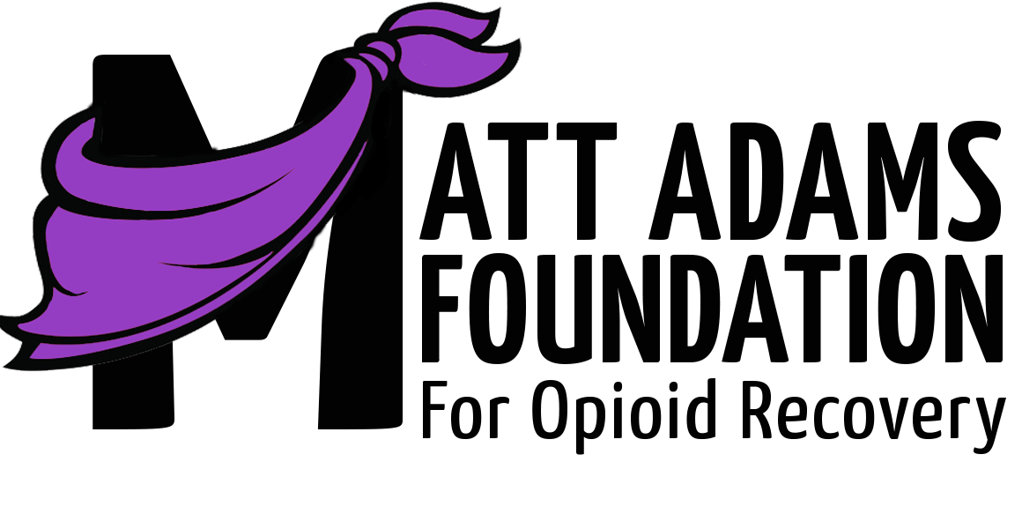

**What is the Matt Adams Foundation?**

The Matt Adams Foundation (MAF) was created in memory of Matt Adams after an accidental overdose. MAF is a 501c3 nonprofit organization which funds distribution of life saving naloxone opioid overdose reversal kits and other harm reduction materials while working to break down the stigma and encourage hope, healing and second chances.

**Where is the foundation located?**

The foundation is located in northwest Arkansas with plans of expanding to other areas.

**What is harm reduction?**

Harm reduction can be personalized to the individual; however, harm reduction refers to a range of public health policies designed to lessen the negative social and/or physical consequences associated with various human behaviors, both legal and illegal.

**What does the foundation offer?**

The foundation offers a variety of harm reduction services such as free Naloxone kits, fentanyl test strips, a confidential hotline, and training sessions about administering Naloxone. The foundations website, mattadamsfoundation.org, also offers links to treatment facilities and information about opioids. The site is also where people can report using a Naloxone kit to save a life.

**What is Naloxone?**

Naloxone is a medicine that rapidly reverses an opioid overdose. It is injected into a person's arm or thigh. In the case of an overdose, naloxone is only a temporary solution. It is encouraged that you call 911 immediately.

**What are Naloxone** **kits?**

The Naloxone kits include two injection needles, two doses of Naloxone, two alcohol prep pads and instructions. The package also includes a QR code that takes you to a video demonstrating how to administer Naloxone. The Matt Adams Foundation has distributed over 6,000 kits free of charge. If you or anyone you know would like your own naloxone kit, please message us at 479-222-0532.

**Who can use the foundations services**

The harm reduction services are available to anyone! The hotline is confidential and free Naloxone kits can be requested at any time.

**Who and how can I donate?**

Anyone can donate to the MAF through the website, mattadamsfoundation.org. Proceeds go towards our efforts to distribute lifesaving harm reduction materials including our naloxone opioid overdose rescue kits and efforts to educate our communities on this critical issue.

**How can I access the foundations services?**

The MAF website, mattadamsfoundaiton.org, is a one stop shop for all of the harm reduction services. It is here that the confidential hotline, free Naloxone kits, and other resources can be accessed.